CV

***Education***

**IQRA TAHIR**

**Computer Operator**

**Personal Information**

**Education**

**Work Experience**

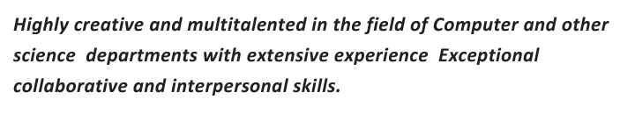***Highly creative and multitalented in the field of Computer and other science departments with extensive experience & Exceptional collaborative and interpersonal skills.* I have vast experience in the field of Computer and consider myself adept in operating computer I assure you of excellent results and output while working for your Institution. Working gives me a lot of skills and experience that I believe make me best suited for the job position that is being offeredwith a position.**

***Husband Name : Mr Tahir Age : 25 CNIC : 34101-52523848***

***Nationality: Pakistani Status : Married Religion : ISLAM***

***Languages : English & Urdu ( Written & Oral)***

**2008-2009**

**Matric in ( Physics , Biology, Chemistry) ( Higher Secondary School Gujranwala Pakistan)**

**2010-2011**

**2012-2013**

**2015-2017**

**FSC in ( Physics, Maths, Computer Science) ( Superior Science College Gujranwala Pakistan)**

**Computer Language( C Language, C++,( Programming) Java, Visual Basic ( Projects Development)( Royal Group of Colleges Gujranwala Pakistan)**

**Graduation in (Computer Science ,Statistics, Accounting) ( University of Allama Iqbal Gujranwala Pakistan)**

**I Have Five Year Experience As an Accountant in Allied Schools Satellite Town Main Campus Gujranwala Pakistan In that period of time I received THE BEST PERFORMANCE AWARD from the MANAGEMENT.**

**I Have Experience As a Trainer For Computer Operator In WAPDA THE GOVERNMENT SECTOR for 1 year**

**I Have Experience As A Teacher In The Best School System Gujranwala Pakistan for 6 Months**

**g**

**CONTACT**

**SKILLS**

**SOFTWARES**

**HOBBIES**

[**iqratahir660@gmail.com**](mailto:iqratahir660@gmail.com)

**00971543722697**

**Al Ain**

Web & Social

Microsoft Access

Digital Art

Drawing

Animation

Corel Draw

Adobe Photoshop

Oracle

MS Office