JAYA CHARITHA
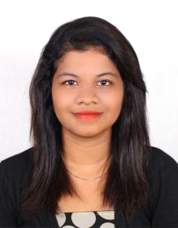
Email ID: laurenclar286@gmai.com
Phone: 8939200450
Objective:
To work for an organization which provides me the opportunity to improve my skills and knowledge to growth along with the organization objective. To work in an organization which helps to explore and an environment to grow.
Qualification:
COURSE | INSTITUTION | PERCENTAGE/  CGPA | YEAR OF PASSING
DIPLOMA | T.S. Srinivasan polytechnic collage of advanced training | 68.93% | 2017
SSLC (STATE BOARD) | St .Johns Mat..Hr .sec. school , Ambattur  ,Chennai-54 | 72 % | 2014

ACHIEVEMENTS:
- Good badminton player
- School level dancer
Special courses:
- Soldering
- Welding
- AutoCAD
Key skills
- 5S
- good command in English oral and written
- good knowledge in quality control
- experience of using Electronics and Electromechanical sensors
- fast grasper
- leadership attitude

Training Undertaken:
i have undertaken training at TVS group companies
- TVS SUNDRAM LUCAS PADI
- 6 MONTHS TIME PERIOD
- DEPT- QUALITY
- TVS SUNDRAM FASTNERS _PADI
- 6 MONTHS TIME PERIOD
- DEPT- QUALITY

PROJECTS HANDLED IN CURRICULAM:
PROJECT: final semester project
Project title: AUTOMATIC STORAGE AND RETRIVAL OF MOBILE SYSTEM
Project Duration: 4 Months [JUNE –DEC 2017]
Applications:
- Schools
- Colleges
- Confidential areas
Description of project:
- This project is about storing and retrieving the mobile with no human interface.
- This project is done with 4stepper motor a microcontroller
- This project is a combination of both mechanical and electronics.
- This human less interface is done by using bar code scanner and sensors

PERSONAL INFORMATION
- Date of Birth : 15-12-1998
- Gender : Female
- Father name : S.D. Deva Jothi Kumar
- Nationality : Indian
- Marital Status : Single
- Languages : English, Hindi, Tamil, Telugu
DECLARATION:

I hereby solemnly declare that the statements made above are true to the best of knowledge and belief.
Date : Signature

