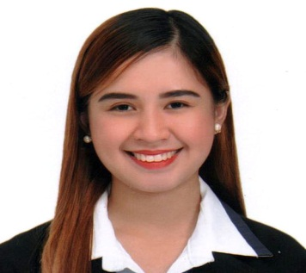
Jyra Jean Q. Tolentino
0929-231-5070
jyrajeantolentino@yahoo.com

OBJECTIVE:
“To become associated with a company where I can utilize my skills and gain further experience while enhancing the company’s productivity and reputation.”

PERSONAL INFORMATION:
Birthdate: September 09,1996
Birthplace: Calapan City, Oriental Mindoro
Age: 22
Address: Brgy. Tawagan Calapan City, Oriental Mdo.
Weight: 43 kg
Height: 5’'1
Mother's Name: Rowena Quinzon Occupation: deceased
Father's Name: Gaudencio Tolentino Occupation: none
Religion: Roman Catholic
Language: English, Tagalog
Civil Status: Single

SKILLS AND QUALIFICATIONS:
- Excellent communication skills both written and oral
- Strong leadership skills
- Computer Literate specially on MS Word, Powerpoint and Excell
- Problem-solving skills
- Ability to work under pressure
- Self-motivated
- Adaptability
- Strong Presentation Skills
- Excellent customer service

EDUCATIONAL BACKGROUND:
- Secondary Education : MinScat Laboratory High School
Masipit Calapan City, Or. Mdo.
2009 – 2013
- Tertiary Education : ACLC College of Calapan
Calapan City, Or. Mdo
2015 – 2019
TRAINING/s and SEMINAR/s:
- Business and IT Seminara
Vencio's Garden and Hotel
2016
- Business and IT Seminar
Calapan Bay Hotel
2017

- College of Business and Entrepreneurship
Administration Training and Seminar
Gaisano Calapan City Branch
2017
- Bangko Sentral ng Pilipinas
Economic and Financial Learning Program
Calapan Bay Hotel
2017
- Business and IT Leadership Training and Seminar
Ferarren Hills , Calapan City
2018
● On-the-Job Training (600 Hours)
ACLC College of Calapan
Calapan City, Oriental Mindoro

REFERENCES:
- Mr. Justine Jose Victa
OJT Supervisor
ACLC College of Calapan

- Ms. Maria Vic Quinto
School Director
ACLC Calapan

- Dr. Rosallie Antonio- Bautista
President
ACLC Calapan

I hereby certify that the above information is true and correct to the best of my knowledge and belief.

Jyra Jean Q. Tolentino
Applicant

