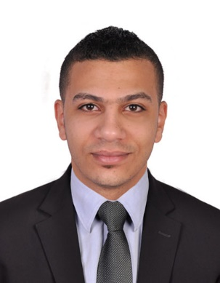
Mohamed Ahmed Fouad
Dubai– U.A.E
Contact: 0568854002
Email: Fo2shagi@gmail.com
Post: Applied For Head Butcher (CDP)

OBJECTIVE
Intend to build a career with leading corporate of Hi-Tech Environment with committed and dedicated people, which will help me to explore myself fully and realize my potential, willing to work as a key player in challenging and creative environment. To make use of the technical skills garnered by me with the outmost commitment and sincerity, to continually learn and broaden my skills and eventually work towards the progress of the company
Education qualification:
Education | Diploma in Industry | Name of Country | Egypt

Employer information: (from recent to previous company)
Company :Emaar hospitality
Industry :Hospitality
Address :The Address Fountain Views Hotel
Position :Head Butcher (CDP)
Date :December 15,2019 Up to present

Company : Grandiose Supermarket LLC.(Ghassan Aboud Group.)
Industry : Retail
Address :Al Barsha St. Dubai UAE
Position :Head Butcher include poultry and seafood
Date :Jan 10,2018 - December 1, 2019
Duties & responsibilities:
- Sharpen and adjust cutting equipment
- Receive, inspect, and store meat upon delivery
- Cut, bone, or grind pieces of meat
- Weigh, wrap, and display cuts of meat
- Cut or prepare meats to specification or customer’s orders
- Store meats in refrigerators or freezers at the required temperature
- Keep inventory of meat sales and order meat supplies
- Clean equipment and work areas to maintain health and sanitation standards
- Experience in Bar B Q Section, Shawarma Section
- Experience marinated section chicken/meat all flavor

Company :AL Zahra food Stuff trading
Industry :Consigner Company
Address :Dubai – Abu Dhabi - Ajman
Position : Butchery Supervisor
Date :December 1, 2014 - November 1, 2017
Address I work

Company :Carrefour
Industry :Carrefour
Address :Egypt – Al gizza
Position :Butcher
Date :Janl 1, 2012 – Jan 1, 2014

Computer skills:
- Microsoft office
- Microsoft power point
- Excel/Outlook
- Using NAV.
- All Products of Adobe
Career related skills:
- Certificate Customer Service
- Certificate Basic Food Hygiene Certificate
- High level skills in butchery

PERSONAL INFORMATION
Date of Birth :February 12, 1994
Place of birth :Egypt
Religion :Muslim
Gender :Male
Marital Status :single
Languages :Arabic English,(read write & speak)
Passport no : A10613784
Expiry date : September 17, 2022
Height : 192.97cm
Personal Strength:
- Proven analytical skills
- Strong Interpersonal skills
- Passion to provide excellent customer service
- Strong problem solving capability
- Desire to get the job done
- Strong negotiation and influencing skills

DECLARATION
I hereby declare that all above information are true and correct according to my knowledge and belief.

Applicant:
Mohamed Ahmed Fouad

