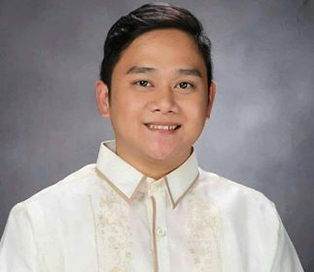
Robert Jhon Paul A. Melano
B-3 L-6 PH.3 Cherry homes SUBD. Mambog 1 Bacoor City
0966-139-4574
ivonemelano@gmail.com

JOB OBJECTIVES

To be a member of an organizational and have opportunity to utilize may acquire knowledge, skills, and expertise needed for future career advancement
EDUCATIONAL BACKGROUND

TERTIARY: UNIVERSIDAD DE MANILA 2018-2019
(BSBA major in ECONOMICS)

SECONDARY: GEN. EMILIO AGUINALDO NAT’L H.S. 2012-2013

ELEMENTARY: IMUS PILOT ELEMENTARY SCHOOL 2007-2008

PERSONAL INFORMATION

AGE: 22 YRS. OLD
SEX: MALE
BIRTH PLACE: MALATE, MANILA
BIRTH DATE: APRIL 19, 1996
CIVIL STATUS: SINGLE

PERSONAL SKILLS

-Easily adoptable in working environment
-hard working
-interpersonal skills
-Good and Proficient Computer Skills
SEMINARS ATTENDED

Technological Innovation through the modernization of Agriculture - September 16, 2016
(Universidad De Manila)

Impact of climate change and food faculty and agricultural sectors - September 16, 2016
(Universidad De Manila)

The Effects of Train Law to the PHILIPPINE ECONOMY - September 16, 2016

DEBT MYTHS: Debunking Common Misconception on Public Debts - October 4, 2018
(Universidad De Manila)

An Economy in Transition: Developing resiliency from repercussions - November 10 2018
(Polytechnic University of the Phil.)

Rocketing Inflation Rate: An Analysis on the Effects of Rising Commodity - October 4, 2018
Prices to the formal sectors in the Philippines
(Universidad De Manila)

The Challenges of the BUILD, BUILD, BUILD Program to the students and - September 21. 2108
Educators for global economy
(Our Lady of Fatima University)

The Implication of and Opportunities from Universal Health Care Bill and - September 11, 2018
Fiscal Incentives Reform
(Polytechnic University of the Phil.)

ACHIEVEMENTS

DEAN’S LISTER 1ST Semester, 3rd Year College - 89.63
DEAN’S LISTER 2ND Semester, 3rd Year College - 89.21
DEAN’S LISTER 1ST Semester, 4th Year College – 89.25
DEAN’S LISTER 2ND Semester, 4th Year College – 93.57

CHARACTER REFERENCES

Mrs. Norma V. Reyes Mrs. Faustina E. Tolentino
Professor/ Economist Professor
09431377751 0940290738

I hereby to certify that the above pieces of information are true and correct

