## Technical Proficiency - Summary

## Educational Qualifications

* **B.Tech, Computer Science Engineering**

AMRITA SCHOOL OF ENGINEERING / Coimbatore, India

## Certifications

* **Microsoft Professional Program in Big Data –** *Pursuing*

Certified by Microsoft

* **ITIL foundation certificate in IT service management**

Certified by AXELOS

* **Basic Android Programming**

Certified by the Hong Kong University of Science and Technology

* **HTML5 Coding Essentials and Best Practices and Advanced Techniques for Designing HTML5 Apps** Certified by W3C Schools
* **Cloud Computing Foundation**

Certified by EXIN

## Experience

**SOFTWARE ENGINEER**

**HCL TECHNOLOGIES/ Chennai, India Aug 2014 – Dec 2017**

Software Tester/Developer in the Aero domain. Worked on developing, configuring and testing various software’s in different platforms.

* Contributed in all phases of the project development lifecycle for in-flight entertainment systems
* Interacted with the stakeholders to identify, analyze and finalize the requirements of the software
* Created various design approach papers, complete with sequence, message transition and flow diagrams
* Developed several software prototypes using Java in Eclipse, for the different design approaches
* Created test case summary, test scripts and test plan documents for the several features being developed
* Performed Unit, Integration, Stress and functional testing in different test environments- Hardware, web and mobile, during various stages of software development
* Identified bugs during testing and review phases. Coordinated with the team to resolve these issues and correct the related documentation

**INTERN | INFOSYS/ Mysore, India | 26 Jan 2014 – 20 May 2014**

* Created an Employee Attendance System web page using C# and .NET framework. Created and maintained a local database to store the registered employee details
* Gained a working knowledge about front-end and back-end development and database connectivity

**INTERN | IBM Chennai, India | 1 June 2012 – 30 June 2012**

* Hands on experience on the various phases of software development
* Basic knowledge about the testing tools used, project specific use of programming languages, use of databases and project management

## Other Information

Nationality: Indian

Date of Birth: 09-06-1993

Marital Status: Married

Languages known: English, Hindi, Tamil, Malayalam and French

Passport Details: Valid up to 20-03-2028

Other Interests: HCL Catalyst team member organizing employee engagement activities, Grade 2 in electronic keyboard from Trinity College, London, Avid reader and oratorical speaker

# SAAI LAKSHMI KANNAN

**Languages**

* C# & .Net
* SQL
* Java
* C & C++

**Tools**

* Android Studio
* Microsoft Azure
* Power BI
* Eclipse

**Certifications**

* ITIL V3
* HTML 5 & CSS
* Android application
* Cloud Computing

**RESUME**

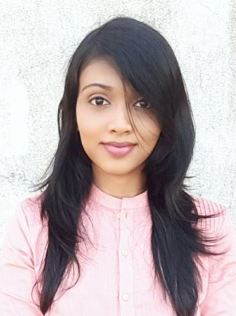

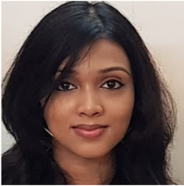

## About Me

A passionate, self-driven software engineer striving to make a positive difference to the organization and teams that I work with, through my enthusiasm, commitment and passion for driving results. My key strengths are in my ability to adapt to new environments, new technologies and collaborative working with stakeholders, differentiated through strong communication and leadership skills.

## Key Skills & Traits

* **Cross Functional Teamwork**

(Between Development, Testing & Analysis, QA and Implementation)

* **ITIL Processes & Best Practices**
* **Test planning and Documentation**
* **Testing tools and techniques**
* **SDLC Process & Practices**
* **Client/Customer Support**
* **Programming Knowledge**
* **Leadership & Team Building**
* **Communication & Presentation**

**• Rational Analysis & Logical thinking**

## Contact Details

 +971-508272497/505698697

 saailakshmi09@gmail.com

 Sharjah, UAE

 linkedin.com/in/saailakshmi-kannan/