CURRICULUM VITAE
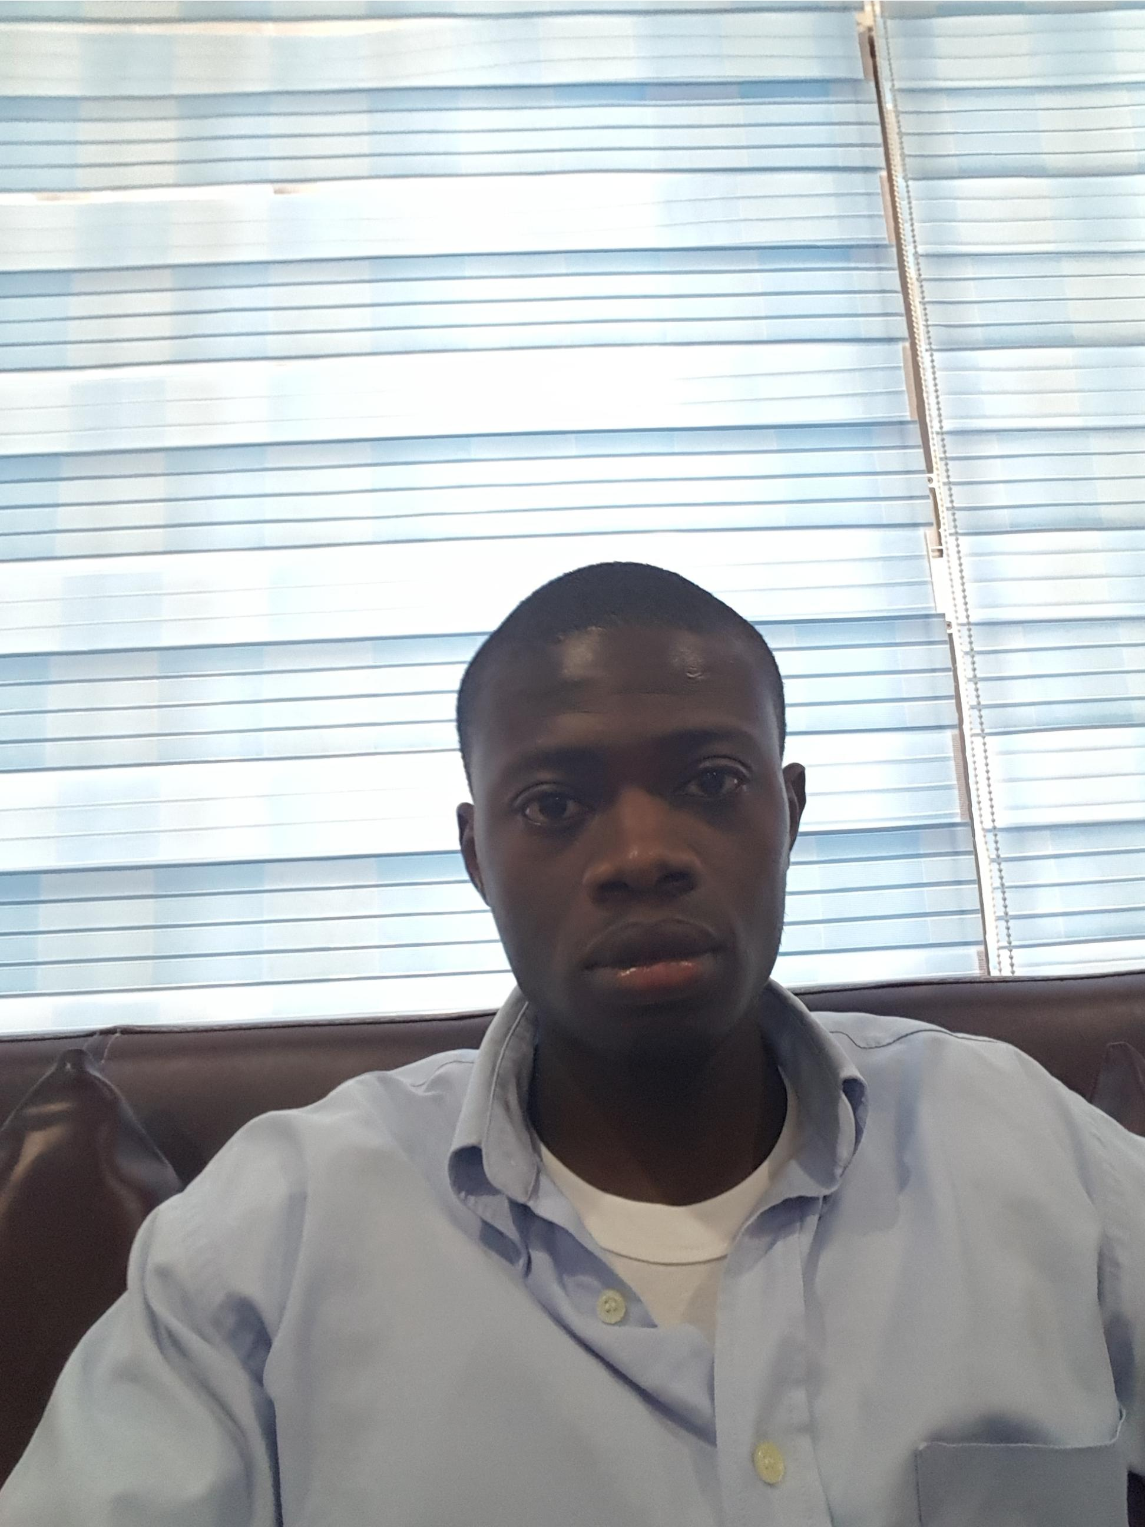
VITALIS CHIMEZIE UNAJI
Mobile: +971 58 940 8893
Email: unajivitalis@gmail.com
Address: 45B Street, Dubai, U.A.E

STEWARD/CLEANER
Professional Summary
Reliable and professional kitchen steward with over 2 years of experience working in restaurants. Strong knowledge of restaurant kitchen cleanliness standards and best practices for keeping things sanitary. Commitment to following all safety procedures and company policies when working with kitchen equipment and tools. Dedicated work ethic and focus on completing each assigned task the right way. Motivated self-starter who has the ability and the desire to work as part of a successful team.
Personal Details
Nationality : Nigerian
Civil status : Single
Date of Birth : 21st September, 1994
Religion : Christianity
Passport No : A10782550
Visa status : Tourist visa
Language : English

Skills
- Dedication to providing excellent customer service to restaurant patrons by keeping cooks and wait staff stocked with supplies.
- Excellent attention to detail, allowing me to spot problems with dishes that didn’t get completely cleaned.
- Strong teamwork skills and commitment to working together with others and supporting people when they need something.
- Works effectively under pressure and where demanding deadlines are present and has the ability to establish achievable goals and objectives.
- During planning and organizing is able to prioritize tasks and assignments.
- Enjoys the challenge of personal development and is able to take on board the teaching of new skills and competencies.
- Builds and maintains relationships at all levels and has the full awareness and focus of providing a good quality service.
- Displays strong interpersonal skills through the ability to contribute effectively in teams events.
- Willing to undergo training and learn new skills.
- Fluent in both oral and written English
- Listens effectively, writes concisely and when making presentations speaks in a persuasive manner.

Work Experience
STEWARD
O’jez Restaurant, Lagos, Nigeria. Two years experience
1 Stacked and put away clean dishes, utensils, pans, and pots after dishwashing cycle was finished so dining room and kitchen area were well stocked.

2 Cleaned the trash area around the outdoor dumpster by breaking down boxes for recycling, removing debris on the ground, and emptying kitchen trash cans.

3 Awarded employee of the month three times during employment with the restaurant because of excellent work ethic and attitude

Dishwasher
Oak Land Hotel, Enugu, Nigeria. Six months experience

1 Cleared and washed all restaurant dishes, cups, pans, containers, and silverware in a busy chain restaurant during dinner shifts.
2 Replenished takeout containers, condiments, sugars, salt and pepper shakers, and napkins throughout the restaurant.
3 Achieved a 98 percent score on restaurant cleanliness inspection when shift supervisors came through the dishwashing station periodically.
Education
- Bachelor’s Degree (B.Engr.) in Agricultural and Environmental Engineering, 2017
- High School Diploma, (WAEC), 2012

Hobbies and Interests
These include:
- Computing
- Reading
- Making Research
- Football
- Music and Films
- Travelling
DECLARATION

I certify that the above information is true and correct to the best of my knowledge and ability. If given the chance to serve you, I assure you that I will execute my duties to the total satisfaction of my superior.

